**UE17CS412-AIR Assignment**

**Dataset**

* The given dataset link consists of 418 csv files.
* Consider each CSV file as an input document. CSV file is a comma separated values file.
* Do the indexing for each csv file.
* Search can be done on one csv or all the csv files.
* It should display the searched row and the document in which it was found.
* Look each csv file as table in a database and URL, MatchDate, Station, Show, IAShowID, IAPreview, Snippet are the columns.

**Note:**

* Don't combine all the csv files into a single file.
* There is no need for redirection to transcript. URL is just a column in the csv.
* Snippet is different for each row and no need to combine snippet also to form a single document.

**Here is a sample output screenshot for indian_foods.csv using elasticsearch**

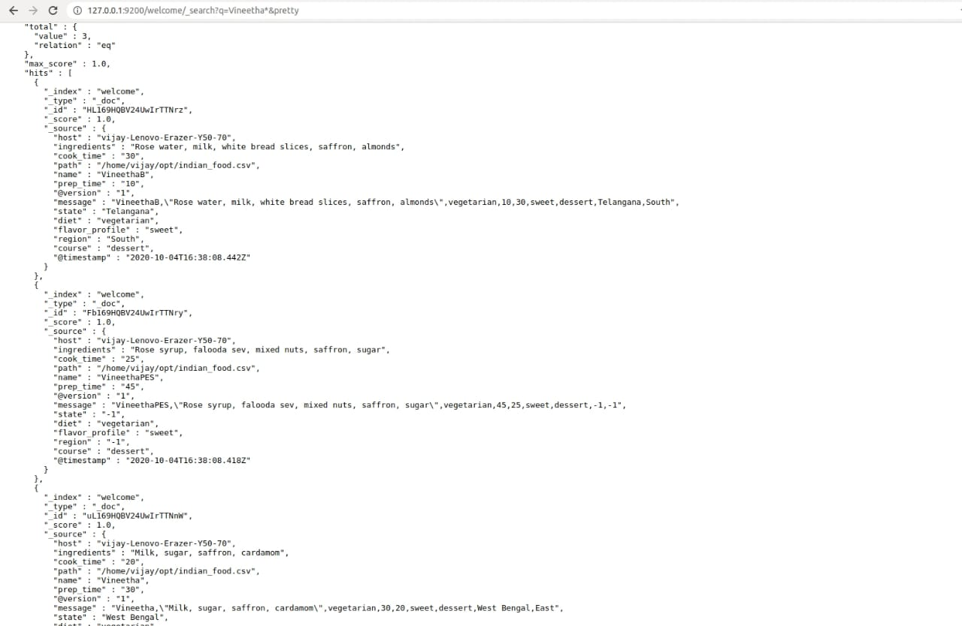

**Fig 2: Search name=Vineetha* in elasticsearch**

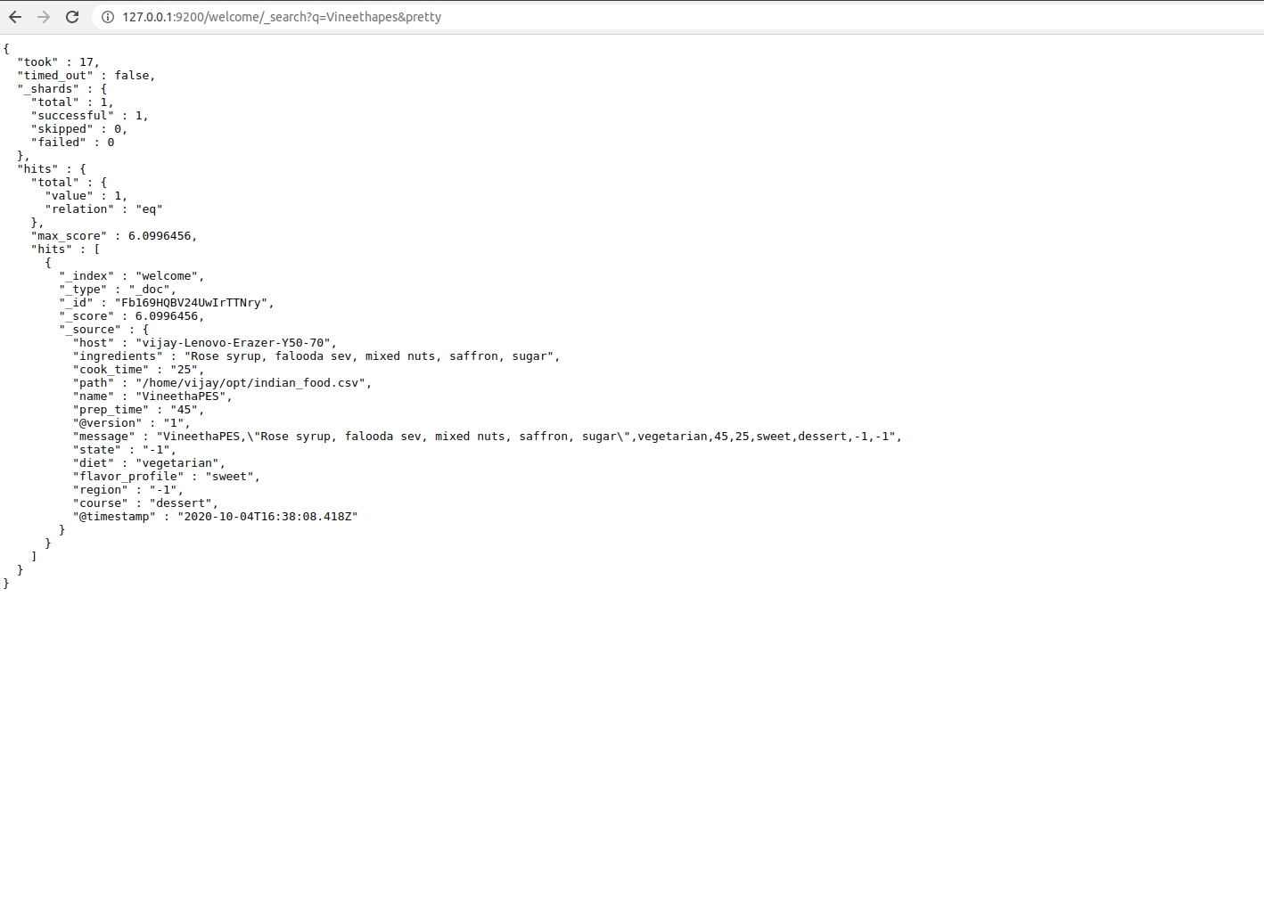

**Fig 2: Search name=Vineethapes in elasticsearch**